**HL DENTAL CLINIC**

**GROUP 4**

**Requirement Specification**

**Members**

|  |  |  |
| --- | --- | --- |
| **No.** | **Full name** |  |
| 1 | Trần Tuấn Anh |  |
| 2 | Chu Bạch Dương |  |
| 3 | Lê Hữu Hiệu |  |
| 4 | Vũ Thị Lan Anh |  |
| 5 | Trần Ngọc Nguyên | Leader |
| 6 | Nguyễn Ngọc Hân |  |
| 7 | Nguyễn Thị Bích Diệp |  |
| 8 | Lê Hải Anh |  |
| 9 | Trịnh Hương Ly |  |
| 10 | Nguyễn Thị Tú Bình | Deputy |

**Document Track Change**

|  |  |  |  |  |  |
| --- | --- | --- | --- | --- | --- |
| **Date** | **Purpose** | **Changes** | **Description** | **Editor** | **Version** |
|  |  |  |  |  |  |
|  |  |  |  |  |  |
|  |  |  |  |  |  |
|  |  |  |  |  |  |

**TABLE OF CONTENT**

1 INTRODUCTION 3

2 BUSINESS OVERVIEW 3

2.1 User Story Map 3

2.2 Overall Structure 3

3 BUSINESS REQUIREMENT 4

4 SPECIFICATION 4

4.1 View Information 4

4.2 Online Order 6

4.3 Manage Order 7

4.4 Payment For Reserve 8

4.5 Treatment History 8

4.6 Precription 9

4.7 Image 9

4.8 Customer Service – FeedBack 10

4.9 Customer Service – Chat/Call with us 11

4.10 Account – SignUp/SignIn 12

4.11 Account – Membership 13

# **1 INTRODUCTION**

HL Dental Clinic Mobile App is a communication channel between customers and clinics, helping customers save time and improve when using services to increase customer experience when coming to HL Dental Clinic System.

# **2 BUSINESS OVERVIEW**

## **2.1 User Story Map**

## **2.2 Overall Structure**

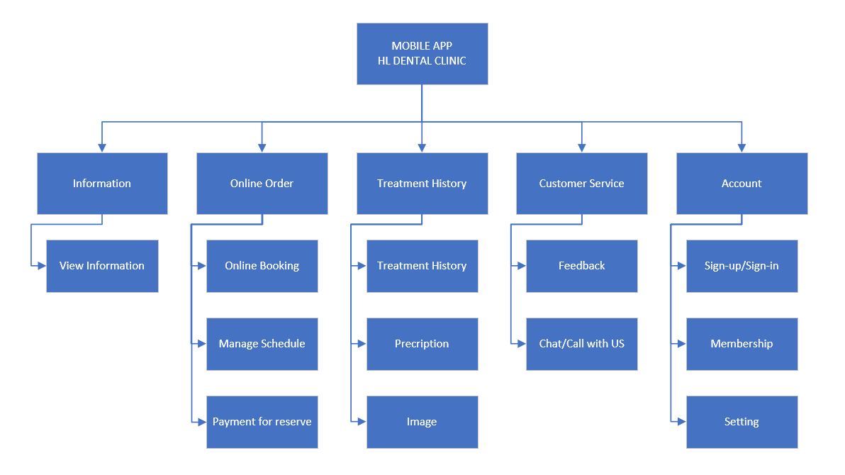

# **3 BUSINESS REQUIREMENT**

# **4 SPECIFICATION**

## **4.1 View Information**

**a) Use case diagram**

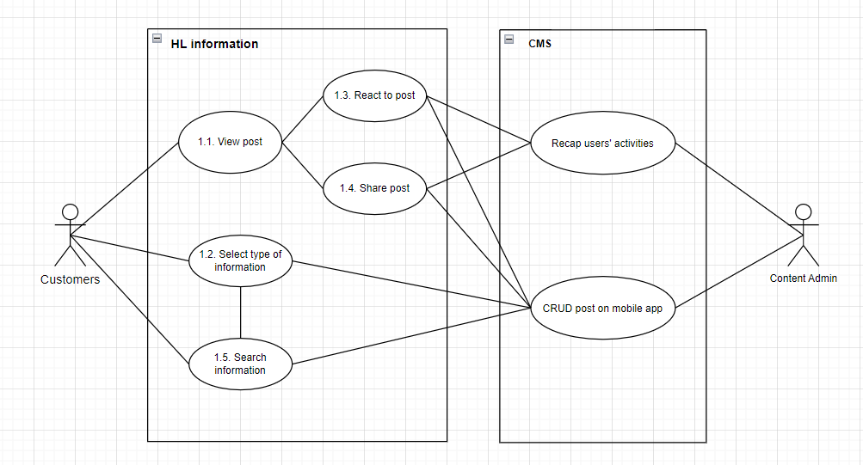

**b) Specification**

|  |  |
| --- | --- |
| **UC Name** | Search information |
| **Actor** | Customers, Content Admin, Content Management System |
| **Description** | As a customer, I want to search for information, to quickly view all related information |
| **Priority** | Low |
| **Trigger** | Customer clicks “search” button on navigation bar |
| **Pre-Condition** | 1. Customer has account and already logged in the mobile app 2. Information/Posts are uploaded into the app |
| **Post Condition** | Customer view the post/information they want |
| **Basic Flow** | 1. Customer clicks “search” button on navigation 2. Customer types in the title of the information they want to search for 3. System returns with all related information 4. Customer selects the information they want to view 5. Customer views the information |
| **Alternative Flow** | 2a. Customer select type of information they want to search for  Use Case continue at step 3.  2b. Customer types in keywords of the information they want to search for  Use Case continue at step 3.  2c. Customer types in keywords of the information they want to search for  2c1. Customer select type of information they want to search  Use Case continue at step 3. |
| **Exception Flow** | 2d. Customer clicks “cancel searching”  Use Case stop.  3a. System finds nothing related  Use Case stop. |
| **Business Rule** | 1. The searching information is in English or Vietnamese  2 The searching information is no longer than 32 words |
| **Non-Functional Requirements** | 1. System has to return results less than 15 second  2. System suggests related information due to each word in searching information |

## **4.2 Online Order**

**a) Use case diagram**

**b) Specification**

|  |  |
| --- | --- |
| **UC Name** | Booking Online HL’s dental clinic |
| **Actor** | Customers, admin |
| **Description** | I want to book an appointment online at HL’s dental clinic |
| **Priority** | high |
| **Trigger** | Open app and click “book schedule” |
| **Pre-Condition** | 1. Customer has a verified account 2. Customer logged in personal account successfully 3. Customer’s device have been connected in internet already |
| **Post Condition** | · Customer created the appointment successfully  · System has noted the successful customer’s booking in schedule |
| **Basic Flow** | 1. Customer select to create booking an appointment  2. Customer select date, time and doctors  3. Customer choose payment methods  4. The system validates the booking information successfully  5. The system notifies the successful transaction on the display screen for customer |
| **Alternative Flow** | 3a. Customer choose payment by credit card  3a1. System switches to the payment screen of the bank selected by the user  3a2. User fill information and select to pay  3a3. The amount has been confirmed by the bank  3a4. The transaction is successful  *Use case continues to step 3*  3b. Customer choose payment by ATM card  3b1. System switches to the payment screen of ATM card  3b2. User fill information and select to pay  3b3. The system confirms the payment has been received  3b4. The transaction is successful  *Use case continues to step 3* |
| **Exception Flow** | 3a3. The payment has been invalid  3a3.1. User choose cancel payment  *Use case stop*  3a3. The payment has been invalid  3a3.1. User choose cancel payment  *Use case stop*  2. The system confirm member account  *Use case continues to step4* |
| **Business Rule** |  |
| **Non-Functional Requirements** | NFR3: timeout for payment information within 3 minutes |

## **4.3 Manage Order**

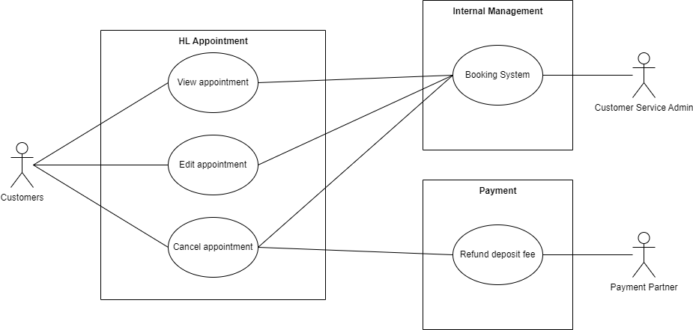

**4.3.1 View appointment**

**a) Use case diagram**

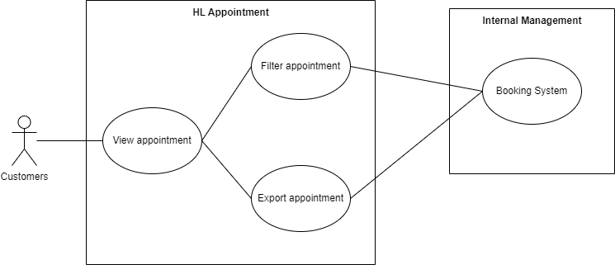

**b) Specification**

|  |  |
| --- | --- |
| **UC Name** | Filter appointment |
| **Actor** | Customers, Internal system |
| **Description** | As a customer, I want to filter my appointments |
| **Priority** | Low |
| **Trigger** | Customer clicks “Filter” in “My appointments” section |
| **Pre-Condition** | 1. Customer has logged in personal account 2. Customer has booked appointments on the system 3. Customer has open the “Schedule” page |
| **Post Condition** | Customers can find the appointments they want |
| **Basic Flow** | 1. Customer clicks “Filter” in “My appointments” section 2. System shows all categories: Branch, Date, Dentist 3. Customer chooses information to filter 4. Customer confirms the search for that information 5. System displays a list of filtered appointments |
| **Alternative Flow** | 3a Customer enters keyword into the search bar  Use Case continue at step 4 |
| **Exception Flow** | 4a Customer clicks cancel button  Use Case stop |
| **Business Rule** | Customer has at least 2 appointments |
| **Non-Functional Requirements** | System has to show results less than 15 seconds |

## **4.4 Payment For Reserve**

**a) Use case diagram**

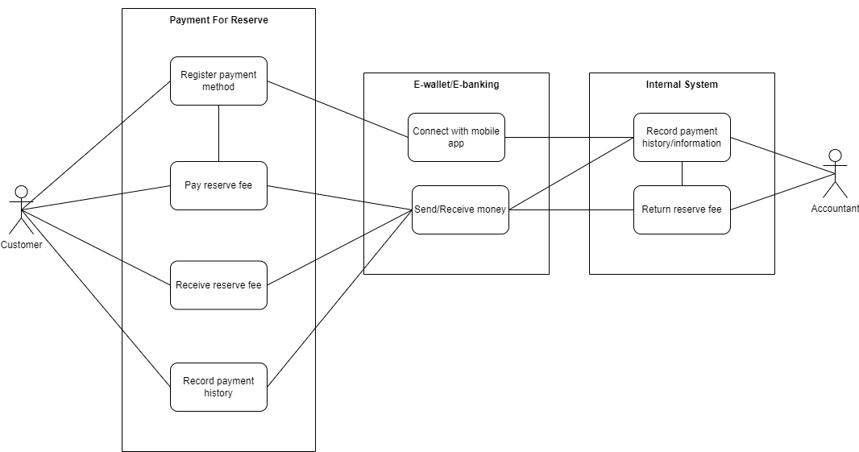

**b) Specification**

|  |  |
| --- | --- |
| **UC Name** | Pay reserve fee |
| **Actor** | Customer, Accountant, Internal System, E-wallet/E-banking system |
| **Description** | As a customer, I want to pay reserve fee to ensure that I have an appointment |
| **Priority** | High |
| **Trigger** | Customer clicks “finish booking appointment” button |
| **Pre-Condition** | 1. Customer has a valid account 2. Customer is not a VIP member 3. Customer opens the “Book appointment” page 4. Customer filled in booking appointment information |
| **Post Condition** | 1. Customer successfully pays reserve fee 2. Customer successfully books an appointment 3. System goes back to main page |
| **Basic Flow** | 1. Customer clicks "finish booking appointment” button 2. System returns with “pay reserve fee” page 3. Customer selects payment method with e-wallet 4. Customer clicks “Pay” button 5. System returns with loading screen 6. E-wallet/E-banking finishes transferring money 7. System returns with “Successfully book schedule” message 8. System updated payment history and sends information to internal system 9. System goes back to main page |
| **Alternative Flow** | 3a. Customer registers payment method with e-wallet  3a1. System moves to the e-wallet app  3a2. Customer clicks “verify the connection”  3a3. System moves back to the mobile app  3a4. Customer selects payment method with e-wallet  Use Case continues at step 4.  3b. Customer selects payment method with card  Use Case continues at step 4.  3c. Customer registers payment method with card  3c1. System opens the “card information” page  3c2. Customer provides card information  3c3. Customer selects payment method with card  Use Case continues at step 7.  3d. Customer selects payment method  3d1. System notifies “Not enough available balance”  3d2. Customer selects another payment method  Use Case continues at step 4. |
| **Exception Flow** | 3e. Customer does not have enough balance  Use Case stop.  4a. Customer clicks “Return” button  4a1. System sends confirmation message  4a2. Customer agrees to stop and returns to the main page  Use Case stop.  6a. E-wallet/E-banking fails to transfer money  Use Case stop. |
| **Business Rule** |  |
| **Non-Functional Requirements** | 1. Payment will be verified within 30 second |

|  |  |
| --- | --- |
| **UC Name** | Receive reserve fee |
| **Actor** | Customer, Accountant, Internal System, E-wallet/E-banking system |
| **Description** | I want to receive return on reserve fee when my appointment was cancelled |
| **Priority** | High |
| **Trigger** | The appointment is cancelled |
| **Pre-Condition** | 1. Customer has a valid account 2. Customer has successfully booked an appointment 3. Customer has paid the reserve fee |
| **Post Condition** | Customer receives money |
| **Basic Flow** | 1. The appointment is cancelled 2. Customer service verifies the cancelled reason 3. Customer service updates customer’s payment condition into being return money 4. Internal system receives information 5. Accountant checks customer payment history and information 6. Accountant makes the return payment to the customer 7. System sends “return money” notification to customer and updates payment history 8. Customer receives money |
| **Alternative Flow** |  |
| **Exception Flow** | 2a. Customer service denies the cancelled reason  Use Case stop. |
| **Business Rule** | 1. Return reserve fee is only accepted with the listed circumstance:  * Doctor could not make the appointment, and customer do not want to make another appointment. * External factors, such as: traffic accidents, holidays, maintenance clinic, and so on. * Every reason will be verified by customer service and updated condition on system. In cases the reason is hard to define, consult the lead team or higher levels for the final decision. |
| **Non-Functional Requirements** |  |

## **4.5 Treatment History**

**a) Use case diagram**

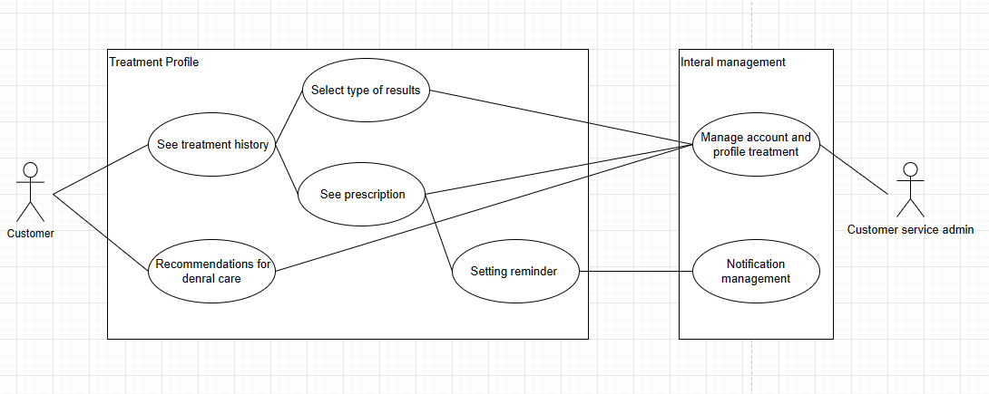

**b) Specification**

|  |  |
| --- | --- |
| **UC Name** | See treatment history |
| **Actor** | Customers, Customer service admin |
| **Description** | As a customer, I want to know the results of my medical exams |
| **Priority** | High |
| **Trigger** | Customer clicks “Treatment history” button |
| **Pre-Condition** | 1. Customer has logged in personal account. 2. Patients has been treated before at dental 3. The patient’s medical history has been updated on the system |
| **Post Condition** | 1. Treatment can see information about treatment history |
| **Basic Flow** | 1. Customer clicks “treatment history” button 2. Customers choose the type of viewing time. 3. Customers select the button “examination results” to see specific results of an examination. 4. Customers choose the type to view medical examination results. 5. The system returns the results that the customer wants to see. 6. Customer views the examination results |
| **Alternative Flow** | 2a. Customers choose to view medical history by month.  *Use Case continue at step 3.*  2b. Customers choose to view medical history by year.  *Use Case continue at step 3.*  2c. Customers choose to see all medical history.  *Use Case continue at step 3.*  4a. Customers choose to see test results.  *Use Case continue at step 5.*  4b. Customers choose to see image results.  *Use Case continue at step 5.* |
| **Exception Flow** | 6a. User selects “home page back” button  *The system returns to the main screen* |
| **Business Rule** |  |
| **Non-Functional Requirements** |  |

## **4.6 Prescription**

**a) Use case diagram**



**b) Specification**

|  |  |
| --- | --- |
| **UC Name** | See Prescription |
| **Actor** | Customers, Customer service admin |
| **Description** | As a customer, I want to know the results of my medical exams |
| **Priority** | High |
| **Trigger** | Customer clicks “Prescription” button |
| **Pre-Condition** | 1. Customer has logged in personal account. 2. Patients has been treated before at dental 3. The patient’s medical history has been updated on the system |
| **Post Condition** | 1. Treatment can see information about Prescription |
| **Basic Flow** | 1. Customer clicks “Prescription” button 2. Customers choose the type of viewing time. 3. Customers select the button “examination results” to see specific results of an examination. 4. Customers choose the type to view medical examination results. 5. The system returns the results that the customer wants to see. 6. Customer views the examination results |
| **Alternative Flow** | 2a. Customers choose to view medical history by month.  *Use Case continue at step 3.*  2b. Customers choose to view medical history by year.  *Use Case continue at step 3.*  2c. Customers choose to see all medical history.  *Use Case continue at step 3.*  4a. Customers choose to see test results.  *Use Case continue at step 5.*  4b. Customers choose to see image results.  *Use Case continue at step 5.* |
| **Exception Flow** | 6a. User selects “home page back” button  *The system returns to the main screen* |
| **Business Rule** |  |
| **Non-Functional Requirements** |  |

## **4.7 Image**

**a) Use case diagram**

**b) Specification**

|  |  |
| --- | --- |
| **UC Name** |  |
| **Actor** |  |
| **Description** |  |
| **Priority** |  |
| **Trigger** |  |
| **Pre-Condition** |  |
| **Post Condition** |  |
| **Basic Flow** |  |
| **Alternative Flow** |  |
| **Exception Flow** |  |
| **Business Rule** |  |
| **Non-Functional Requirements** |  |

## **4.8 Customer Service – Feedback**

**a) Use case diagram**

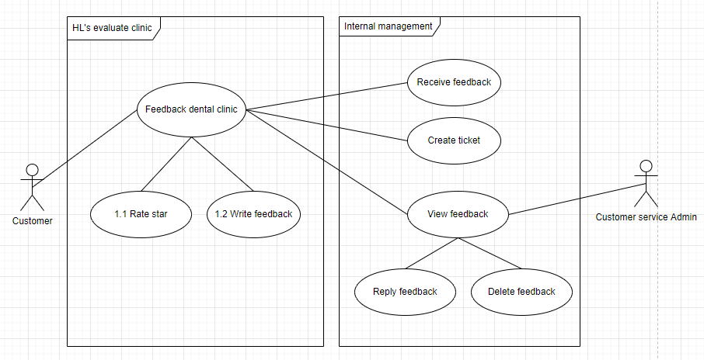

**b) Specification**

|  |  |
| --- | --- |
| **UC Name** | Feedback HL’s dental clinic |
| **Actor** | Customers, Customer service admin |
| **Description** | As a customer, I want to evaluate HL’s dental clinic to improve service quality |
| **Priority** | Low |
| **Trigger** | Customer clicks “feedback” button on navigation bar |
| **Pre-Condition** | 1. Customer has account and already logged in the mobile app 2. Customer used dental service at clinic 3. The app must prompt customers to evaluate recent visits to dental clinics. |
| **Post Condition** | Customer receives message “Submit feedback successfully” |
| **Basic Flow** | 1. Customer clicks the “feedback” button 2. The app displays evaluation form 3. Customer provides a rating and write feedback for the material facilities and professional quality. 4. Customer clicks submit feedback and receives message “feedback successfully” 5. Customer service admin view the customer’s evaluation and checks feedback |
| **Alternative Flow** | 2a. Customer clicks “Home page back”  2a1. App displays "You want to leave this page?” 2a2. Customer clicks “Stay” button  *Use Case continue at Step 3*  3a. The customer only rating service (not write feedback)  *Use Case continue at step 4* |
| **Exception Flow** | 2b. Customer clicks “feedback later” button  *Use Case stop.*  2b1. Customer clicks “Home page back”  2b2. App displays "You want to leave this page?” message 2b3. Customer clicks “Leave” button  *Use Case stop*  4a. The customer encounters an error while providing feedback, such as an issue with the internet connection.  *Use Case stop.*  4b. The app displays an error message and prompts the customer to try again later.  *Use Case stop.* |
| **Business Rule** | 1. The customer's evaluation must meet the app's content policy and cannot contain any inappropriate language or personal information. 2. Customer only sends feedback within 30 days. |
| **Non-Functional Requirements** | 1. Security: The app must ensure that the customer's personal information is protected and not shared with any third parties. |

**c) Activity diagram:**

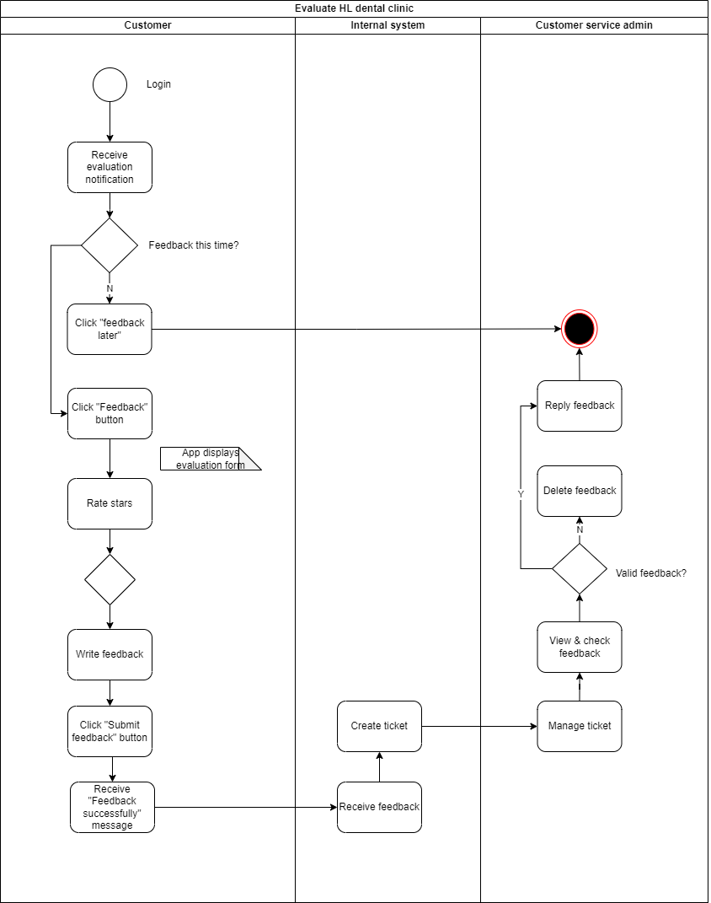

## **4.9 Customer Service – Chat/Call with us**

**a) Use case diagram**

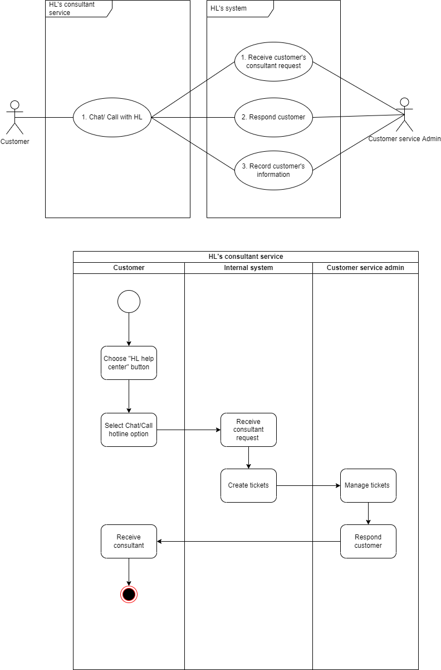

**b) Specification**

|  |  |
| --- | --- |
| **UC Name** | Consultant service |
| **Actor** | Customers, Customer service admin |
| **Description** | As a customer, I want to connect directly with customer service of dental clinic to find support |
| **Priority** | High |
| **Trigger** | Customers click “HL help centre” button on navigation bar |
| **Pre-Condition** | 1. Customer has account and already logged in the mobile app 2. Customer has used dental service at clinic before |
| **Post Condition** | 1. Customer receives advice and recommendations from customer services |
| **Basic Flow** | 1. Customer clicks “HL help centre” button on navigation bar. 2. The app displays three option “Chat with us”, “call hotline”, and “I’ll be back later” 3. Customer provide their needs 4. Customer service admin gives recommendations. |
| **Alternative Flow** | 2a. Customer chooses “send messages to us”  *Use case continues at step 3.*  2b. Customer chooses “call with us”  *Use case continues at step 3.* |
| **Exception Flow** | 2b. Customer chooses “I’ll be back later”  *Use case stops.* |
| **Business Rule** |  |
| **Non-Functional Requirements** | Security: Customers’ personal information must be protected. |

## **4.10 Account – SignUp/SignIn**

**a) Use case diagram**

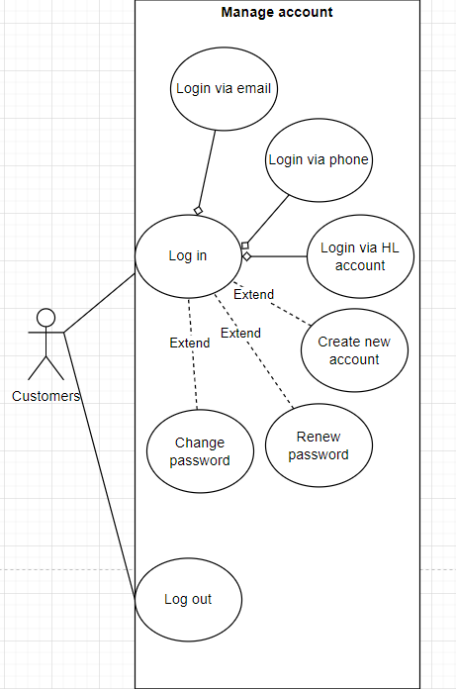

**b) Specification**

|  |  |
| --- | --- |
| **UC Name** |  |
| **Actor** |  |
| **Description** |  |
| **Priority** |  |
| **Trigger** |  |
| **Pre-Condition** |  |
| **Post Condition** |  |
| **Basic Flow** |  |
| **Alternative Flow** |  |
| **Exception Flow** |  |
| **Business Rule** |  |
| **Non-Functional Requirements** |  |

**c) Activity diagram**

## **4.11 Account – Health conditions**

**a) Use case diagram**

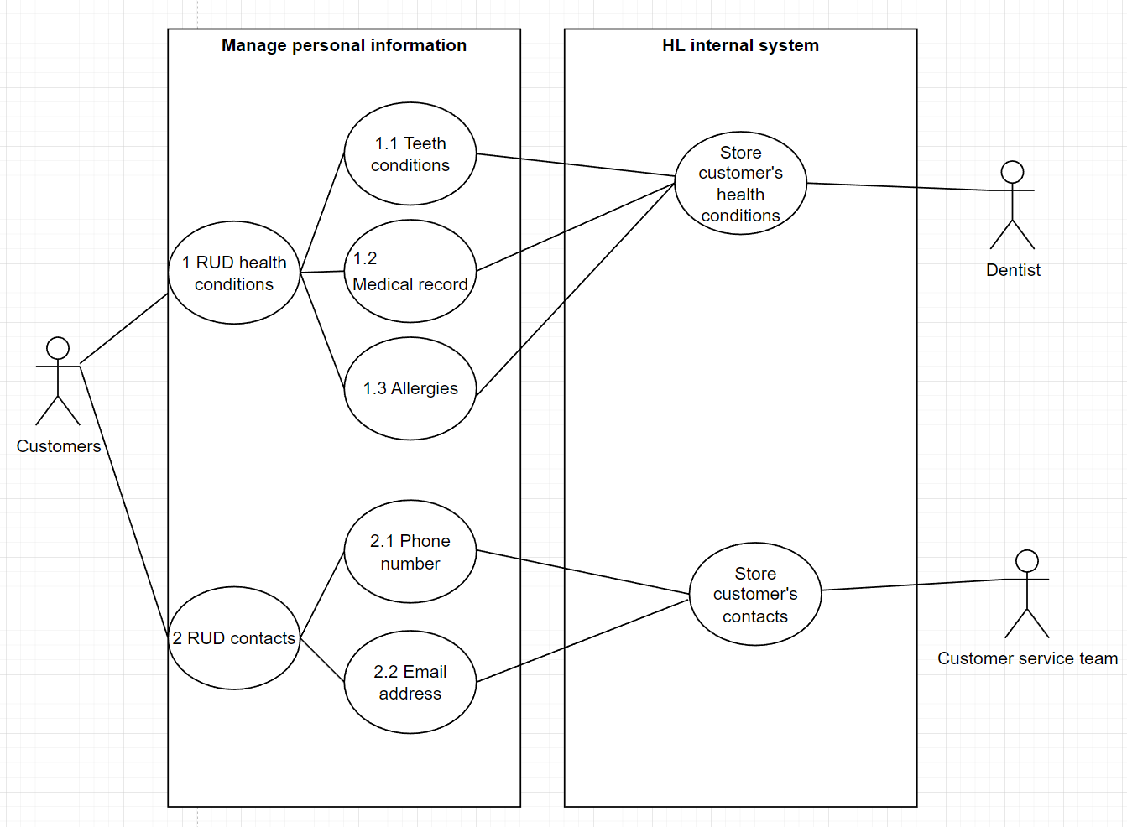

**b) Specification**

|  |  |
| --- | --- |
| **UC Name** | Update health conditions |
| **Actor** | Customers, dentists, customer service team |
| **Description** | As a customer, I want to update my health conditions, so that I can receive appropriate treatments |
| **Priority** | Medium |
| **Trigger** | Customer clicks the “update” button in the health conditions section |
| **Pre-Condition** | 1. Customers logged in HL Dental mobile app 2. health conditions information is lacking or does not match with the user’s current information |
| **Post Condition** | Customer able to update their newest health conditions |
| **Basic Flow** | 1. Customers clicks the “account” button on navigation bar 2. Customers choose “setting” section 3. Customers choose “health conditions” section 4. System display following information  * Teeth conditions * Medical record * Amnesia  1. Customers click “update” buttong on desired section 2. Customers updating the information 3. Customers clicks “Finish update” 4. System shows “Update successfully” 5. System records customers information in the app and in HL dental’s internal system |
| **Alternative Flow** |  |
| **Exception Flow** | 6.a Customer clicks “cancel update”  Use Case stop at 6 |
| **Business Rule** |  |
| **Non-Functional Requirements** |  |

**c) Activity diagram**

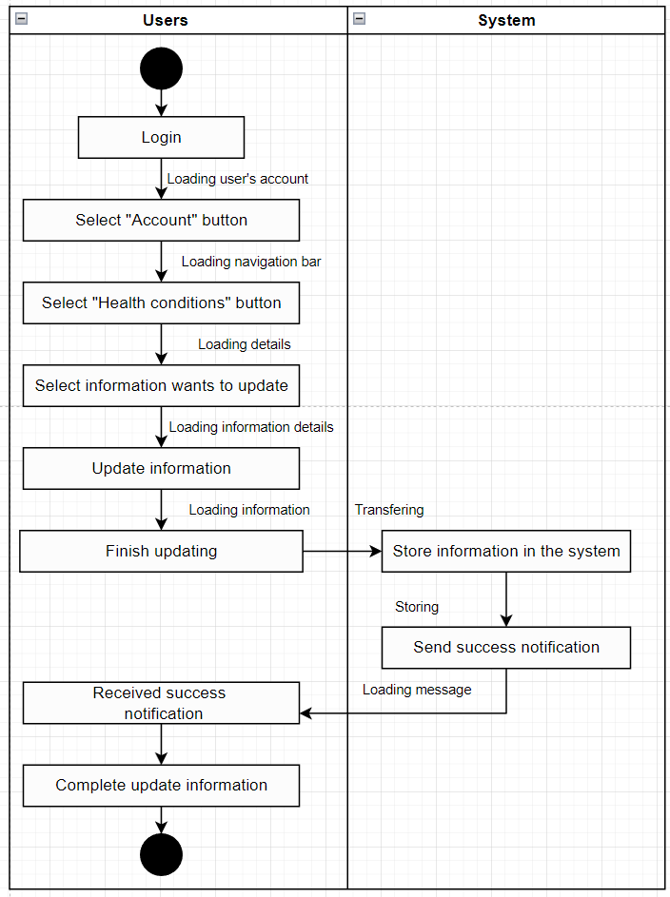

## **4.12 Account – Membership**

**a) Use case diagram**

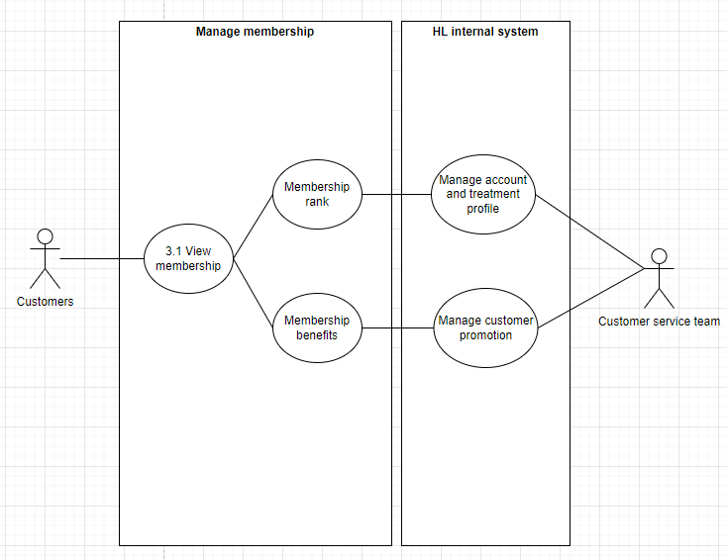

**b) Specification**

|  |  |
| --- | --- |
| **UC ID** | UC |
| **UC Name** | View membership status |
| **Actor** | Customers, customer service team |
| **Description** | As a customer, I want to view my membership status, so that To know which level of membership I have |
| **Priority** | Low |
| **Trigger** | Customer clicks the “Membership” button in the "Account” section |
| **Pre-Condition** | * Customers logged in HL Dental mobile app |
| **Post Condition** | * Customer able to view all of the information relevant to their membership status |
| **Basic Flow** | 1. Customers clicks the “Account” button on navigation bar 2. Customers choose “Membership” section 3. System fetch customer’s information from database 4. System displays following information  * Customer’s membership rank * Information on how to rank up * Benefits  1. Customers successfully view the relevant information |
| **Alternative Flow** |  |
| **Exception Flow** | 3.a Customer clicks “Back” button  Use Case stop |
| **Business Rule** |  |

**c) Activity diagram**

